**Sprint 2 Review**

**Meme Feed**

**Meme Teme**

**2/12/19**

**Revision 0**

* **Actions to stop doing:** 
  + Getting distracted during meetings
* **Actions to start doing:** 
  + Manage individual time better (3hrs a day)
  + Finishing tasks
  + Taking photos of scrum board
  + Updating the scrum board
* **Actions to keep doing:** 
  + Working together as a team
  + Debug together
  + Finishing tasks
* **Work completed/not completed:** 
  + Not completed
  + Around ⅞ completed
* **Work completion rate:** 
  + Sprint 1: 1 user stories completed, 20 total ideal hours completed across 14 days
    - Stories/day : 0.7
    - Ideal work hours / day: 1.4
  + Sprint 2: 5 user stories completed, 53 total ideal hours completed across 14 days
    - Stories/day : 0.36
    - Ideal work hours / day: 3.79
  + All Sprints: 6 user stories completed, total ideal hours completed across 28 days
    - Stories/day : 0.21
    - Ideal work hours / day: 2.61

**Final Burnup Chart:**

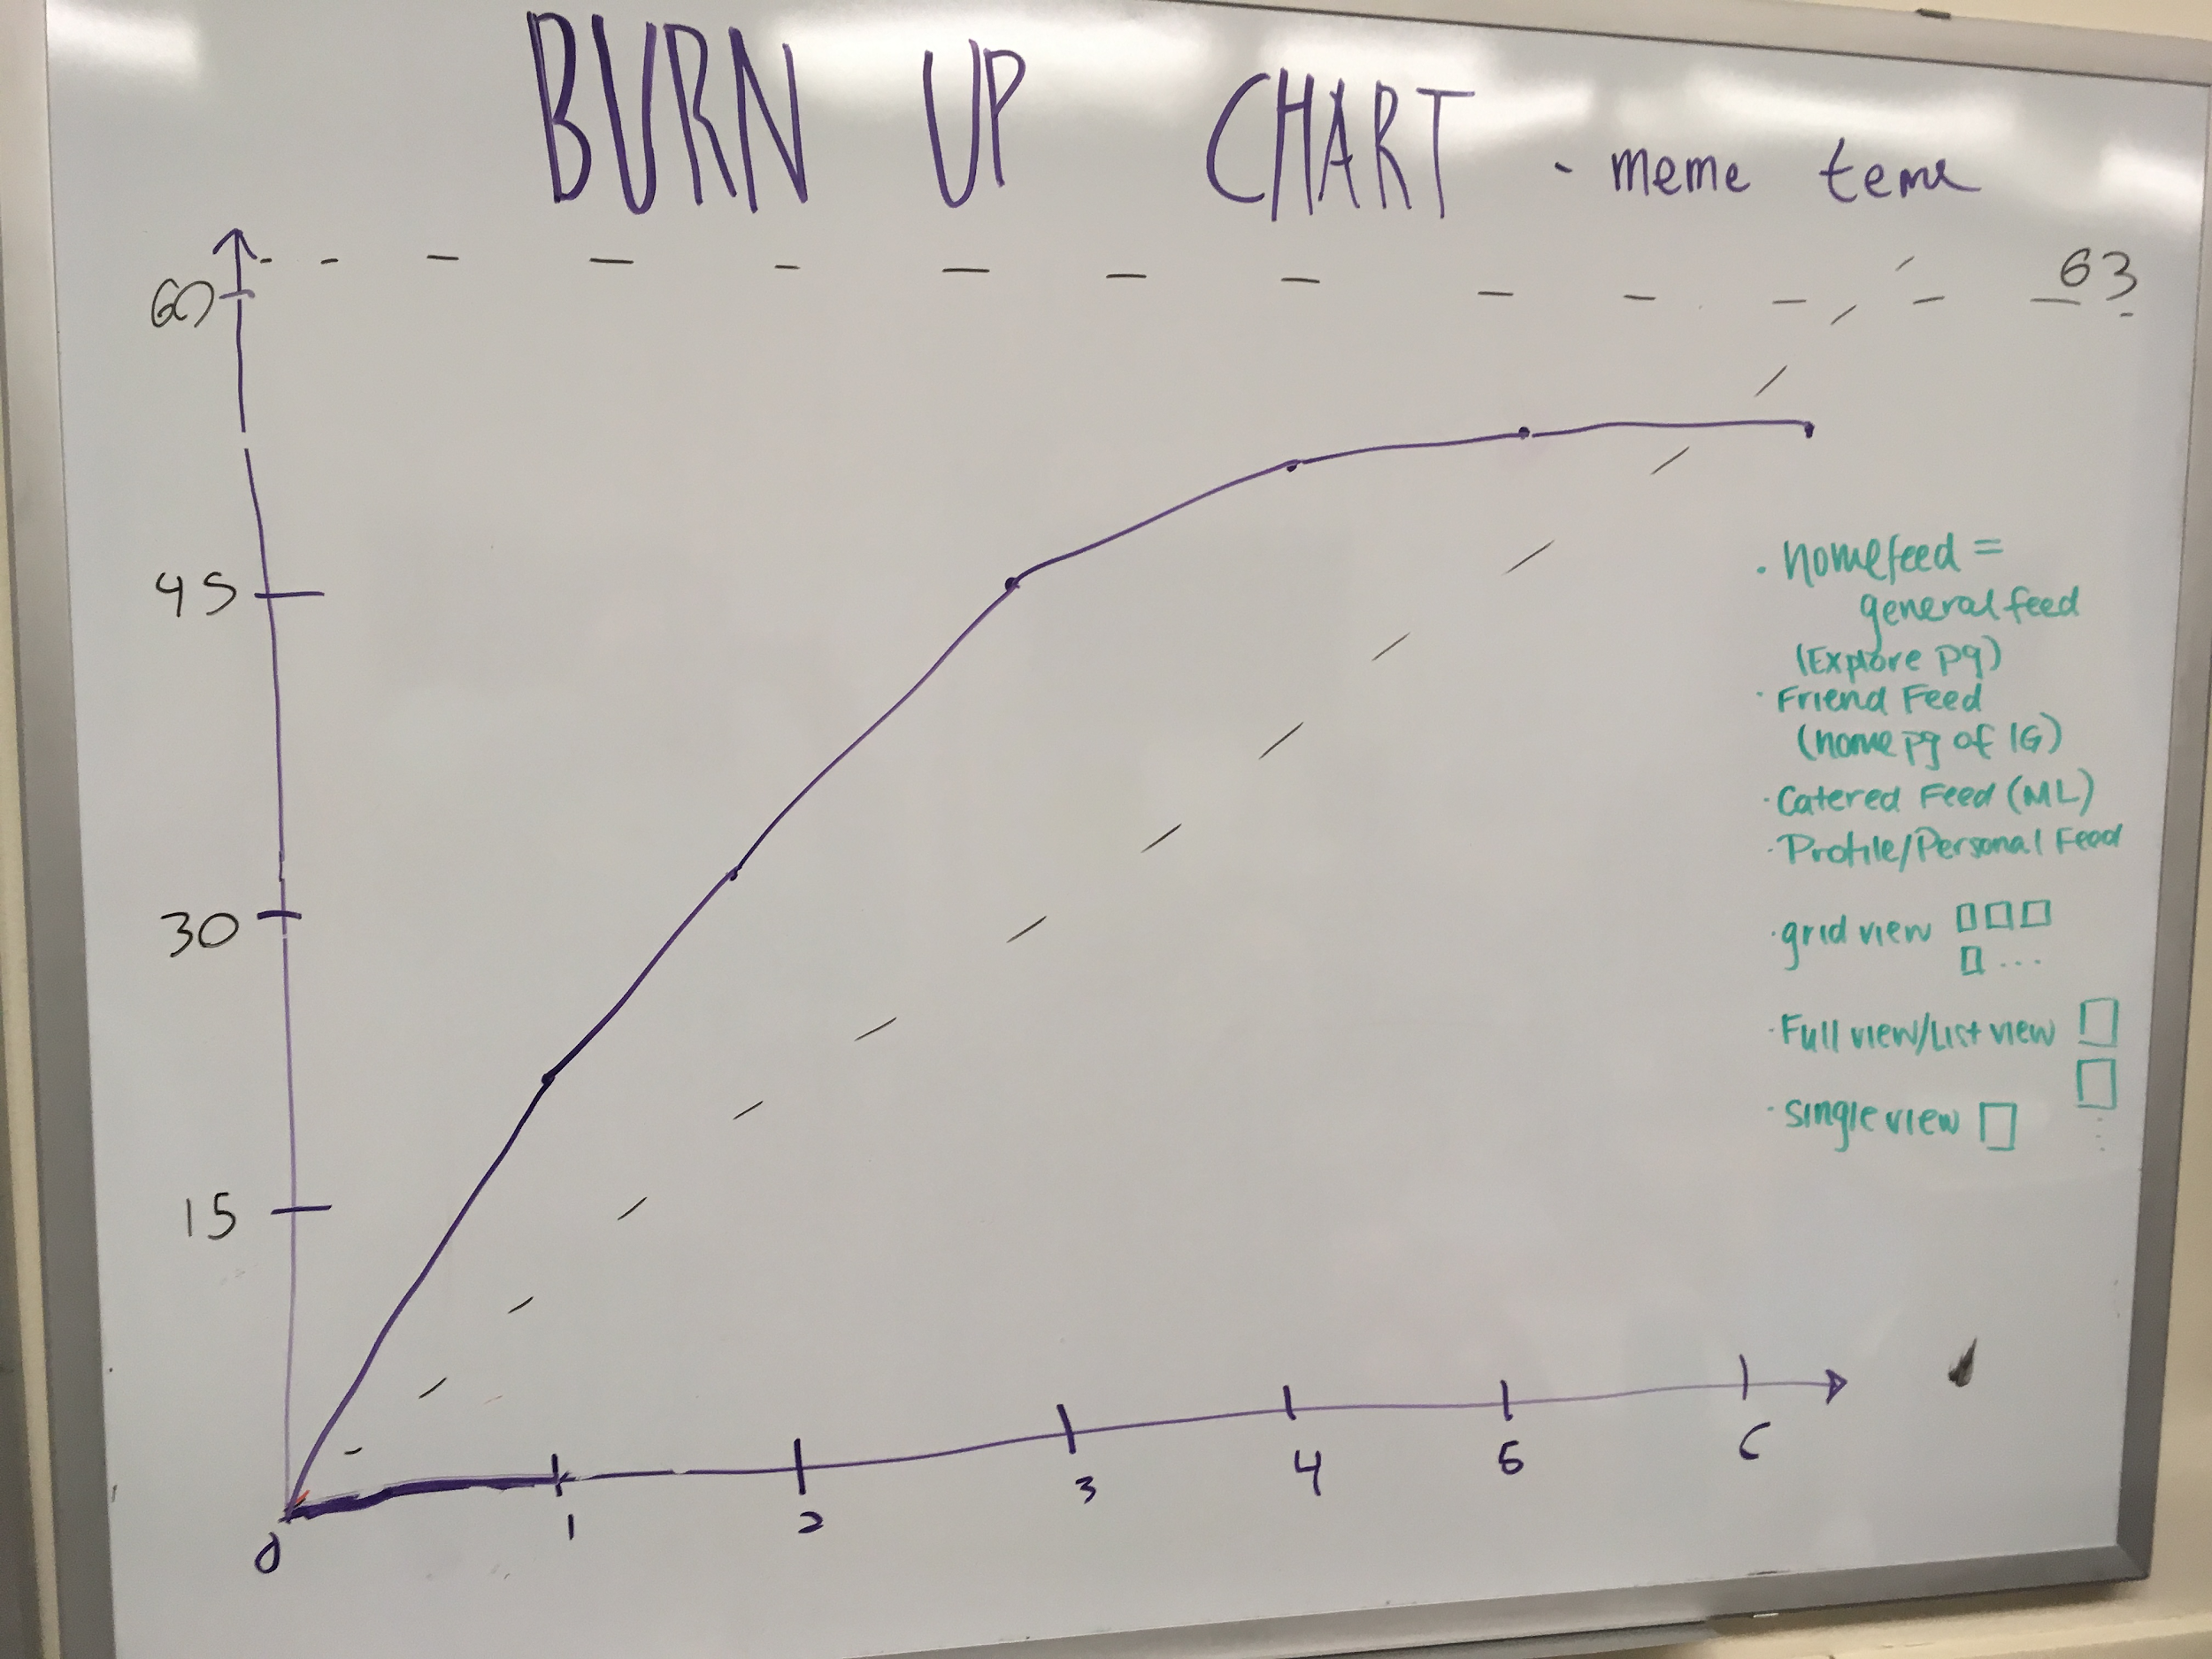

**Final Scrum Board:**

